Abstract title here. 13pt, bold. Upper and Lower case.

Robert Leeª*, Andrew Coleª, Warren Barton^{b}

ª School of Chemical Engineering and Advanced Materials, Newcastle University, Newcastle upon Tyne, NE1 7RU, UK
^{b} Affiliation no.2, Address 1, Address 2, Address 3, POST CODE, UK
* Corresponding author. Email robert.lee@emaildomain.ac.uk

Main Body of Abstract here in 11pt text. Please use times new roman throughout. Abstract title in 13pt bold text. Author names in 11pt bold text. Affiliation in 9pt text. Text alignment of main text: justified. Please use 1.0 line spacing and leave a single blank line between paragraphs. Include any references in brackets using the surname, year format as in (Aneke et al, 2012). Full reference should be included at end of abstract.

Figures and tables may be included but the total abstract length should not exceed 1 A4 page (including any references). Note: Abstract booklet will be printed in black and white but a full colour version will be made available online.

Table 1. Caption to appear above the table in 11pt bold (centre alignment).

Heat Source Temperature  (ºC) | Pre-Heater / Evaporator Duty  (kW) | Net Power Output  (kW) | Plant Thermal Efficiency  (%)
140 | 500 | 70.0 | 14.0
95.0 | 780 | 66.3 | 8.50

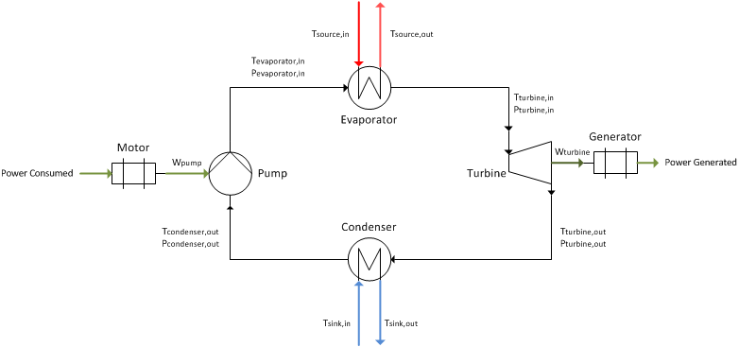
Figure 1. Caption to appear below the figure in 11pt bold (centre alignment)

References (title in 11pt bold)

Aneke, M. Agnew, B. Underwood, C. Wu, H. Masheiti, S. (2012) Power Generation from Waste Heat in a Food Processing Application, Applied Thermal Engineering 36, pp 171-180.

(Reference list in 10pt text)

